

Tribhuvan University
Faculty of Humanities and Social Sciences

Internship Report
On
Software Development

In partial fulfillment of the requirements for the degree of Bachelor of Computer Applications

Submitted to:
Department of Computer Application
Swastik College
Chardobato, Bhaktapur

Submitted by:
Anjan Khadka (113102067)

Under the Supervision of
Sujan Poudel

July 2026



Tribhuvan University
Faculty of Humanities and Social Sciences

Internship Report
On
Software Development

In partial fulfillment of the requirements for the degree of Bachelor of Computer Applications

Submitted to:
Department of Computer Application
Swastik College
Chardobato, Bhaktapur

Submitted by:
Anjan Khadka (113102067)

Under the Supervision of
Sujan Poudel

July 2026

Certificate of complition

Mentor reccomendation

Tribhuvan University
Faculty of Humanities and Social Sciences
Swastik College
Chardobato, Bhaktapur

SUPERVISOR’S RECOMMENDATION
I hereby recommend that this project prepared under my supervision by ANJAN KHADKA entitled “Internship Report on Software Development” in partial fulfillment of the requirements for the degree of Bachelor of Computer Application is recommended for the final evaluation.

………………………..
Sujan Poudel
SUPERVISOR
Swastik College
Chardobato, Bhaktapur


Tribhuvan University
Faculty of Humanities and Social Sciences
Swastik College
Chardobato, Bhaktapur

LETTER OF APPROVAL
This is to certify that this project prepared by ANJAN KHADKA entitled “Internship Report on Software Development” in partial fulfillment of the requirements for the degree of Bachelor in Computer Application has been evaluated. In our opinion, it is satisfactory in the scope and quality as a project for the required degree.

……………………………  Mr. Sujan Poudel  Internship Supervisor  Swastik College | ……………………………  Ms. Susan Sunuwar  Coordinator  BCA Department, Swastik College
……………………………  Internship Mentor  Er. Ujjwal Srivastav  Scriipt lab | ……………………………  External Examiner  (lecturer, FOHSS YU)

ACKNOWLEDGEMENT

I would like to express my sincere gratitude to Mr. Sushil Bashyal, Founder of Webbing Plex, for providing me with the opportunity to undertake my internship at the organization. This internship allowed me to gain practical exposure to the software development environment and understand professional workplace practices.
I am deeply thankful to Mr. Ramesh Sapkota, Project Manager, for his guidance, coordination, and support throughout the internship period. His encouragement and valuable suggestions helped me understand the workflow of software development projects.
I would also like to express my heartfelt appreciation to Mr. Ujjwal Srivastav, Senior Software Engineer and my mentor, for his continuous guidance, technical support, and willingness to share his knowledge. His mentorship helped me improve my understanding of modern web development practices and encouraged me to approach problems with confidence.
I extend my sincere thanks to all the members of the development team and my fellow interns for creating a friendly and collaborative working environment. Their cooperation, discussions, and support made my internship both enjoyable and a valuable learning experience.
Finally, I would like to express my heartfelt gratitude to the Department of Computer Science and Information Technology, my teachers, internship coordinator, and Tribhuvan University for providing me with the opportunity and academic support to complete this internship successfully.
I am grateful to everyone who directly or indirectly contributed to the successful completion of my internship and this report.

With Regards:
Anjan Khadka

ABSTRACT

This internship report presents the knowledge, practical experience, and technical skills gained during a three-month internship at Webbing Plex under the Script Lab department. The internship provided an opportunity to work in a professional software development environment and contribute to the development of real-world web applications. Throughout the internship, I collaborated with senior developers and fellow interns while working on multiple ongoing company projects, including e-commerce platforms, business directory systems, and corporate websites.
The internship involved various software development activities such as frontend development, API integration, responsive user interface implementation, debugging, code refactoring, manual testing, technical documentation, and version control. During this period, I gained practical experience with modern web technologies including Next.js, React, TypeScript, Laravel, Express.js, RESTful APIs, HTML, CSS, JavaScript, Git, GitHub, Postman, and Visual Studio Code. I also developed a better understanding of software architecture, project workflows, collaborative development practices, pull request management, and communication within an Agile development environment.
This report describes the organization, the working environment, the technologies used, the tasks performed, and the knowledge acquired throughout the internship. It also discusses the challenges encountered, the solutions adopted, and the professional and technical skills developed during the internship. Overall, the internship successfully bridged the gap between academic learning and real-world software development practices, providing valuable industry exposure and strengthening my foundation for a professional career in software engineering.
Keywords: Internship, Web Development, Next.js, React, TypeScript, Laravel, Express.js, REST API, Frontend Development, API Integration, Software Engineering, Git, Postman.

Table of Contents

SUPERVISOR’S RECOMMENDATION iv
LETTER OF APPROVAL v
ACKNOWLEDGEMENT vi
ABSTRACT vii
LIST OF TABLES x
LIST OF FIGURES xi
LIST OF ABBREVIATIONS xii
CHARPTER 1: INTRODUCTION 2
1.1 Introduction 2
1.2 Problem Statement 3
1.3 Objectives 3
1.4 Scope and Limitation 4
1.4.1 Scope 4
1.4.2 Limitation 5
1.5 Report Organization 7
CHAPTER 2: Introduction to Organization 8
2.1 Organization Details 8
2.1.1 Services 9
2.1.2 Technologies Used 10
2.1.3 Roles and Responsibilities 10
2.1.4 Working Environment 11
2.1.5 Development Workflow 12
2.2 Organizational Hierarchy 12
2.3 Working Domains of Organization 12
2.4 Description of Intern Department/Unit 12
CHAPTER 3: SYSTEM ANALYSIS AND DESIGN 13
3.1 System Analysis 13
3.1.1 Requirement Analysis 13
3.1.2 Feasibility Analysis 16
3.1.3 Data Modeling: ER Diagram 18
3.1.4 Process Modeling (DFD) 19
3.2 System Design 21
3.2.1 Architectural Design 21
3.2.2 System Flowchart 22
3.2.3 Database Schema Design 23
3.2.4 Interface Design (UI/UX) 24
3.2.5 Physical DFD 26
3.2.6 Sequence Diagram 27
3.3 Algorithm Details 28
Chapter 4: Implementation and Testing 33
4.1 Implementation 33
4.1.1 Tools Used 33
4.1.2 Implementation Details of Modules 34
4.2 Testing 36
4.2.1 Test Cases for Unit Testing 36
4.2.2 Test Cases for System Testing 43
Chapter 5: Conclusion and Future Recommendations 46
5.1 Lesson Learnt/ Outcome 46
5.2 Conclusion 46
5.3 Future Recommendations 46
References 47
APPEDNICES 48

LIST OF TABLES
Table 3. 1: Gantt Chart Table For Chat Application 13

Table 4. 1: Test Case for Authentication Module 33
Table 4. 2: Test Case for Profile Module 34
Table 4. 3: Test Cases for Direct Messaging Module for Chat Application 35
Table 4. 4: Test Cases for Channel Module for Chat Application 37
Table 4. 5: Test Case for System Testing for Chat Application 39

LIST OF FIGURES
Figure 3. 1: WaterFall Model For Chat Application 9
Figure 3. 2: Use Case Diagram For Chat Application 11
Figure 3. 3: Gantt Chart For Chat Application 14
Figure 3. 4: ER Diagram For Chat Application 15
Figure 3. 5: Level 0 DFD For Chat Application 16
Figure 3. 6: Level 1 DFD For Chat Application 17
Figure 3. 7: Architectural Design For Chat Application 18
Figure 3. 8: System Flowchart For Chat Application 19
Figure 3. 9: Database Schema Design For Chat Application 20
Figure 3. 10: Empty Chat Dashboard 21
Figure 3. 11: Direct Message Dashboard 21
Figure 3. 12: Channel Message Dashboard 22
Figure 3. 13: Profile Setup Dashboard 22
Figure 3. 14: Physical Level DFD for Chat Application 23
Figure 3. 15: Sequence Diagram For Chat Application 24

LIST OF ABBREVIATIONS

API Application Programming Interface
CSS Cascading Style Sheets
DB Database
DBMS Database Management System
DFD Data Flow Diagram
HTTP HyperText Transfer Protocol
HTTPS HyperText Transfer Protocol Secure
JSON JavaScript Object Notation
JWT JSON Web Token
MERN MongoDB, Express.js, React.js, Node.js
NoSQL Not Only SQL
REST Representational State Transfer
UI User Interface
URL Uniform Resource Locator
UX User Experience

CHARPTER 1: INTRODUCTION

Introduction
The software industry requires developers to possess not only theoretical knowledge but also practical experience in building, maintaining, and improving real-world applications. An internship provides an opportunity to bridge the gap between academic learning and professional software development by exposing students to industry standards, collaborative workflows, and modern development technologies.
This internship was carried out at Webbing Plex Pvt. Ltd. under the Script Lab department as part of the Bachelor of Computer Application (BCA) program of Tribhuvan University. During the internship, I worked alongside senior software engineer and fellow developer interns on several ongoing company projects rather than a single application. These projects included e-commerce platforms, corporate websites, business directory systems, and internal software solutions that were being actively developed for clients.
Throughout the internship, I participated in various stages of the software development lifecycle. My responsibilities included frontend development, API integration, responsive user interface implementation, debugging, code refactoring, manual testing, technical documentation, and collaboration through Git-based version control. Working on multiple projects enabled me to understand different software architectures, development workflows, coding standards, and project management practices followed in a professional software company.
The internship also provided exposure to modern web development technologies such as Next.js, React, TypeScript, Laravel, Express.js, RESTful APIs, HTML, CSS, JavaScript, Git, GitHub, Postman, and Visual Studio Code. In addition to technical skills, I improved my communication, teamwork, problem-solving ability, documentation practices, and understanding of Agile-based software development.
This report presents an overview of the organization, the internship environment, the technologies used, the tasks performed, the knowledge and skills acquired, the challenges encountered, and the overall learning experience throughout the internship period. It reflects how the internship helped strengthen my technical foundation while preparing me for a professional career in software development.

Problem Statement
Academic courses provide students with a strong theoretical foundation in programming, software engineering, databases, networking, and system analysis. However, classroom learning alone is often insufficient to prepare students for the challenges of professional software development. Modern software projects require developers to work collaboratively, follow coding standards, integrate APIs, use version control systems, maintain existing applications, and communicate effectively within a development team.
Organizations also face the challenge of continuously improving and maintaining software products while adapting to changing client requirements. This involves debugging existing systems, implementing new features, improving user interfaces, ensuring responsive design, performing software testing, and preparing technical documentation without affecting the stability of the application.
The internship at Webbing Plex provided an opportunity to address these challenges by allowing practical participation in real-world software development activities. Working on multiple client projects exposed me to industry-standard tools, collaborative development practices, software maintenance, testing procedures, and modern web technologies, thereby helping bridge the gap between academic knowledge and professional practice.

Objectives
The internship was conducted to fulfill the academic requirements of the Bachelor of Computer Application (BCA) program while providing practical exposure to professional software development. The objectives of this internship report are categorized as follows.
General Objective:
To document the knowledge, practical experience, and professional skills gained during the internship at Webbing Plex Pvt. Ltd., and to fulfill the internship requirement of the Bachelor of Computer Application (BCA) program under Tribhuvan University.
Specific Objectives:
- To introduce Webbing Plex Pvt. Ltd., including its organizational structure, services, departments, and working environment.
- To understand the professional software development process followed by the company while working on real-world client projects.
- To gain practical experience in modern web development technologies, including Next.js, React, TypeScript, Laravel, Express.js, RESTful APIs, Git, and related development tools.
- To improve technical skills through frontend development, API integration, debugging, responsive design implementation, software testing, code refactoring, and technical documentation.
- To understand collaborative software development practices such as version control, pull requests, code reviews, task management, and team communication.
- To enhance professional skills including problem-solving, teamwork, communication, time management, and adaptability in a software development environment.
- To relate the theoretical knowledge acquired during the BCA program with practical industrial experience gained throughout the internship.

1.4 Scope and Limitation

1.4.1 Scope
The internship offered practical exposure to different aspects of modern web application development within a professional software development environment. Instead of working on a single project, I contributed to several ongoing client projects under the guidance of senior software engineer and collaborated with fellow developer interns.
The scope of the internship included:
- Understanding the software development lifecycle followed by the organization.
- Developing and maintaining frontend components using modern web technologies.
- Integrating and testing RESTful APIs.
- Debugging software issues and implementing bug fixes.
- Improving responsive user interfaces for desktop, tablet, and mobile devices.
- Performing manual testing and validating application functionality.
- Preparing technical documentation and reporting implementation details.
- Using Git and GitHub for version control, pull requests, and collaborative development.
- Participating in code reviews, technical discussions, and team meetings.
- Learning industry best practices related to software architecture, clean code, and project organization.

1.4.2 Limitation
Although the internship provided valuable practical learning opportunities, several limitations were encountered during the internship period.
- Most projects were ongoing client projects; therefore, only assigned modules and tasks could be accessed and modified.
- Some project requirements, business logic, and backend implementations were confidential and could not be included in this report.
- Certain implementations required review and approval from senior developers before deployment, limiting independent decision-making.
- The internship duration was limited, making it difficult to experience the complete software development lifecycle from project planning to production deployment.
- Since some projects were still under development, several planned features had not yet been completed or released during the internship period.
- Access to production servers, deployment infrastructure, and sensitive client data was restricted for security reasons.
- Due to project deadlines and changing priorities, some tasks focused on maintenance, testing, debugging, and documentation rather than complete feature development.
Despite these limitations, the internship provided meaningful industry exposure and significantly enhanced both my technical competencies and professional development.

1.5 Report Organization
This internship report is organized into five chapters, each describing a different aspect of the internship experience.
Chapter 1: Introduction presents the background of the internship, problem statement, objectives, scope, limitations, and the overall organization of the report.
Chapter 2: Introduction to Organization describes Webbing Plex Pvt. Ltd., including the company background, organizational structure, Script Lab department, services offered, working environment, development process, and technologies used within the organization.
Chapter 3: Internship Activities explains the roles and responsibilities assigned during the internship. It presents the projects I contributed to, the technologies and tools used, the development workflow, daily responsibilities, and the practical tasks performed throughout the internship.
Chapter 4: Learning Outcomes and Discussion highlights the technical and professional skills gained during the internship, challenges encountered, solutions adopted, lessons learned, and the relationship between academic knowledge and industrial practice.
Chapter 5: Conclusion and Recommendations summarizes the overall internship experience, evaluates the knowledge and skills acquired, and provides recommendations for future interns, the organization, and the university to further enhance the internship program.

CHAPTER 2: Introduction to Organization

2.1 Organization Details
This chapter provides an overview of the organization where the internship was conducted. It describes the company's background, services, organizational structure, development environment, technologies used during the internship, and the overall working environment. Understanding the organization and its workflow helped in relating academic knowledge to professional software development practices.
Webbing Plex Pvt. Ltd. is a software development company based in Nepal that develops web applications and provides software solutions for businesses and organizations. The company works on a variety of client projects, including e-commerce platforms, business directory systems, corporate websites, and other customized web-based applications. The development team follows a collaborative approach in which project planning, development, testing, and code review are carried out as a team to deliver quality software solutions.
During my internship, I was assigned to the Script Lab department, where I worked with senior software engineers and fellow developer interns. The internship provided exposure to real-world software development practices, including collaborative coding, API integration, debugging, testing, documentation, and version control.


Table 2.1: Organization Overview
Particular | Description
Company Name | Webbing Plex Pvt. Ltd.
Department | Script Lab
Industry | Software Development and IT Services
Internship Position | Software Developer Intern
Internship Duration | Three Months
Location | Nepal

2.1.1 Services
Webbing Plex provides software development services for different business requirements. During the internship, I observed that the company focuses primarily on designing, developing, and maintaining web-based software solutions for its clients.
The major services offered by the company include:
- Custom web application development
- API integration and backend services
- UI/UX implementation and responsive web development
- Software maintenance and enhancement
- Technical consulting and project support

2.1.2 Technologies Used
Throughout the internship, different modern technologies and development tools were used depending on the project requirements. The primary technologies that I worked with are listed below.
Table 2.2: Development Technologies
Category | Technologies
Frontend | Next.js, React, TypeScript, HTML5, CSS3, JavaScript
Backend | Laravel, Express.js
API | RESTful APIs
Database | MySQL, MongoDB (project dependent)
Version Control | Git, GitHub
Testing | Postman, Manual Testing
Development Tools | Visual Studio Code

2.1.3 Roles and Responsibilities
As a Software Developer Intern, my responsibilities included assisting the development team in different software development activities. Depending on project requirements, my work involved both implementation and support tasks.
My primary responsibilities included:
- Developing and improving frontend user interfaces.
- Integrating frontend components with backend APIs.
- Debugging and resolving software issues.
- Performing responsive design implementation for different screen sizes.
- Conducting API testing and manual system testing.
- Preparing technical documentation and implementation reports.
- Using Git and GitHub for version control, pull requests, and collaborative development.
- Participating in technical discussions.

2.1.4 Working Environment
The working environment at Webbing Plex was collaborative and learning-oriented. Throughout the internship, I had the opportunity to work under the guidance of experienced software engineers while collaborating with fellow developer interns on multiple projects.
Tasks were generally assigned after discussions with the project manager or senior developer. Team members regularly communicated regarding implementation approaches, issue resolution, testing results, and project progress. Pull requests and code reviews were part of the development workflow, allowing developers to receive feedback before code was merged into the main branch.
The internship also encouraged continuous learning. Along with assigned development tasks, I explored new technologies, studied existing codebases, and gained practical experience with software development tools, project organization, and professional workplace communication. This environment helped me improve both my technical knowledge and my ability to work effectively as part of a software development team.

2.1.5 Development Workflow
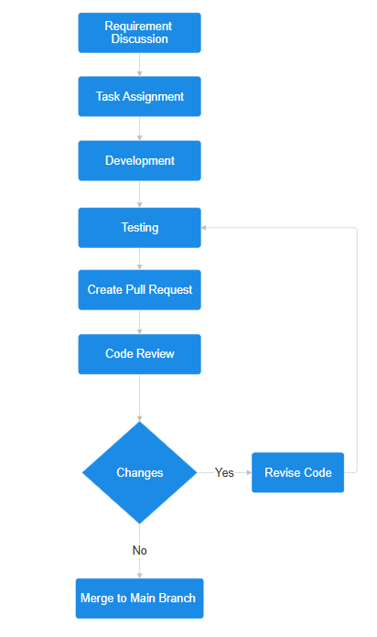

2.2 Organizational Hierarchy

2.3 Working Domains of Organization

2.4 Description of Intern Department/Unit

CHAPTER 3: SYSTEM ANALYSIS AND DESIGN

3.1 System Analysis
This system was designed with the series of processes starting with requirement analysis, design, coding, testing, implementation and documentation. During requirement analysis, all the functional and nonfunctional requirement were analyzed and system was developed according to the requirement then designing of the system was carried out. After the design process, coding and development part was started then after integrating the system there was testing of the system. Testing was positive so system came in operation then followed by documentation.
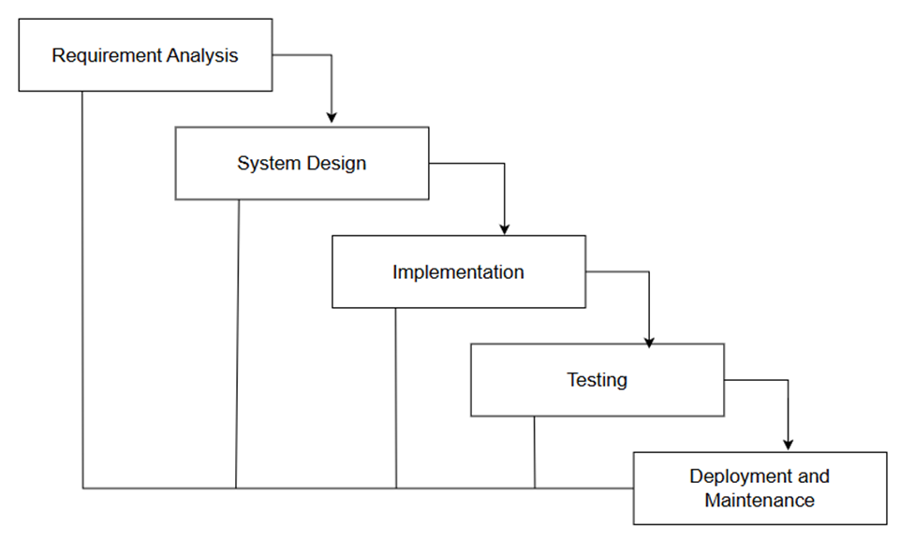
Figure 3. 1: WaterFall Model For Chat Application

3.1.1 Requirement Analysis
i) Functional Requirements
- User Management
The system must allow users to register, log in, and log out securely. User authentication should be handled using JWT tokens to ensure secure access. The system should manage user profiles, maintain login sessions, and restrict unauthorized access to chat features.
- Real-Time Messaging
The application must support real-time personal and group messaging using socket-based communication. Messages sent by a user should be instantly delivered to the recipient without requiring page refreshes, ensuring smooth and continuous interaction.
- Message Encryption and Decryption
The system must implement a custom encryption algorithm to encrypt messages before storing them in the database. When messages are retrieved, they should be decrypted so that users can read them normally. This ensures confidentiality and protects sensitive communication data.
- Group Chat and Personal Chat Management
The system should allow users to create group chats, add and remove members and participate in both personal and group conversations. This functionality supports collaborative and social communication.
- File and Media Sharing
Users should be able to upload and share files and images within chat conversations. The system must support file storage using Multer and allow users to download shared files easily.
- Emoji and Message Interaction Support
The application should support emojis in messages to enhance user interaction and make conversations more expressive and engaging.
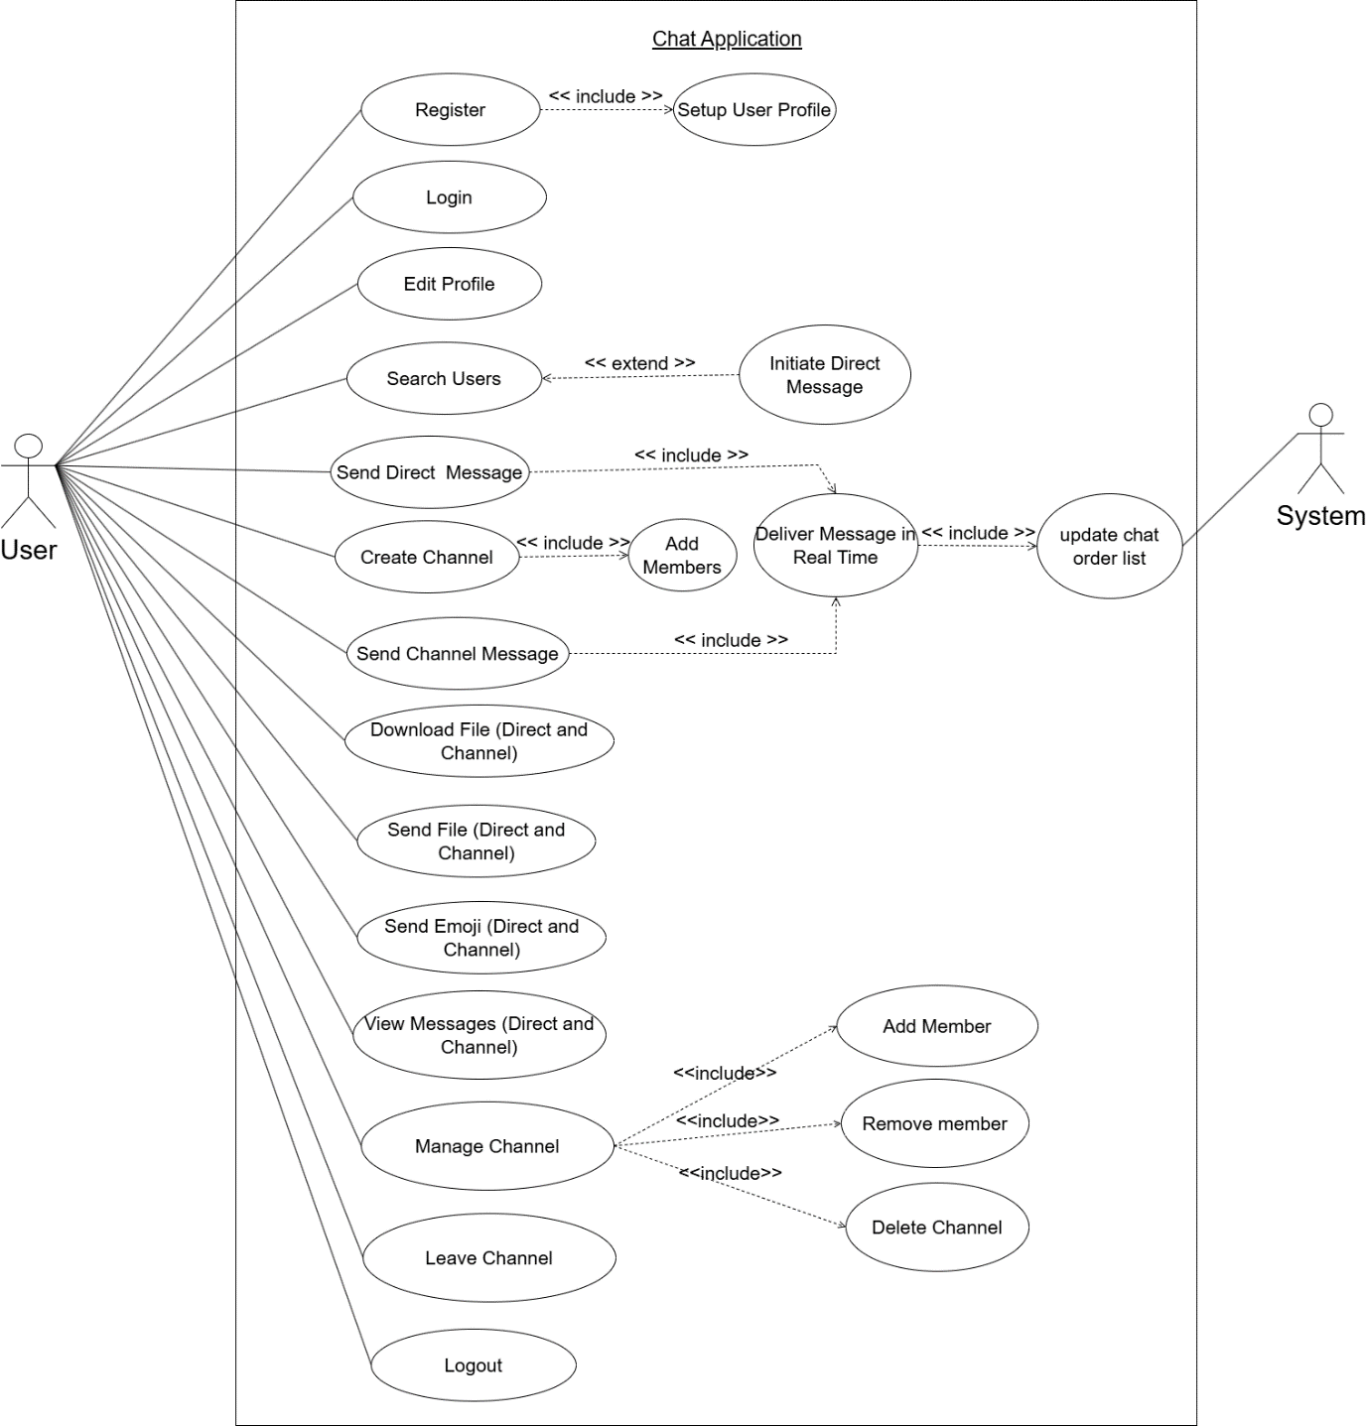
Figure 3. 2: Use Case Diagram For Chat Application
ii) Non-Functional Requirements
- Usability
The system should have a clean, intuitive, and responsive user interface developed using React, Tailwind CSS, and ShadCN UI components. Users should be able to navigate and use the application easily without requiring technical knowledge.
- Performance
The application must deliver fast response times for sending and receiving messages. It should efficiently handle multiple users and concurrent chat sessions without noticeable delays or performance degradation.
- Security
User credentials, messages, and shared files must be protected using secure authentication mechanisms and encryption techniques. JWT-based authentication and encrypted message storage ensure that only authorized users can access communication data.
- Reliability
The system should operate consistently without frequent crashes or data loss. Proper error handling, stable server performance, and reliable database operations must ensure uninterrupted communication, even during high user activity.

3.1.2 Feasibility Analysis
The feasibility study evaluates whether the development of the proposed Chat Application using the MERN stack is practical and achievable. The key aspects considered in this study are technical, economic, operational, and schedule feasibility.
- Technical Feasibility
Technical feasibility examines whether the required technologies and technical skills are sufficient to develop the proposed system. The Chat Application is developed using widely adopted web technologies such as MongoDB, Express.js, React, and Node.js. These technologies are well-documented, actively supported, and compatible with modern web environments. Real-time communication is implemented using socket-based technology, while JWT is used for secure authentication. File handling is managed using Multer, and state management is handled through Zustand. Since all these tools are open-source and do not require specialized hardware or proprietary software, the system is technically feasible and can be deployed on standard computing infrastructure.
- Economic Feasibility
The proposed system is economically feasible as it relies entirely on open-source frameworks and libraries. There are no licensing costs associated with the development tools, database, or runtime environment. The application can be developed and tested using standard personal computers, minimizing hardware expenses. By providing an efficient digital communication platform, the system reduces dependency on external messaging tools and manual coordination methods. In the long term, the application helps save time and resources by streamlining communication and reducing operational inefficiencies.
- Operational Feasibility
Operational feasibility assesses whether the system will function effectively within its intended environment. The Chat Application offers real-time messaging, secure authentication, group and personal chats, file sharing, and emoji support, all of which align with modern user expectations. The intuitive and responsive user interface ensures ease of use for users without technical expertise. Additionally, the implementation of message encryption enhances trust and data privacy. These features collectively improve communication efficiency and ensure smooth daily operation of the system.
- Schedule Feasibility
Schedule feasibility evaluates whether the system can be completed within the allocated time frame. The development process can be divided into well-defined phases such as requirement analysis, system design, frontend and backend development, testing, and deployment. Each phase is manageable based on the project’s scope and complexity. With proper planning and time management, the Chat Application can be developed and delivered within the proposed schedule. Therefore, the project is considered feasible from a scheduling perspective.
Table 3. 1: Gantt Chart Table For Chat Application
Task Name | Duration (Days)
Planning | 15
Analysis | 15
Design | 20
Coding & Testing | 66
Delivery | 7
Documentation | 108
Total (Days) | 123

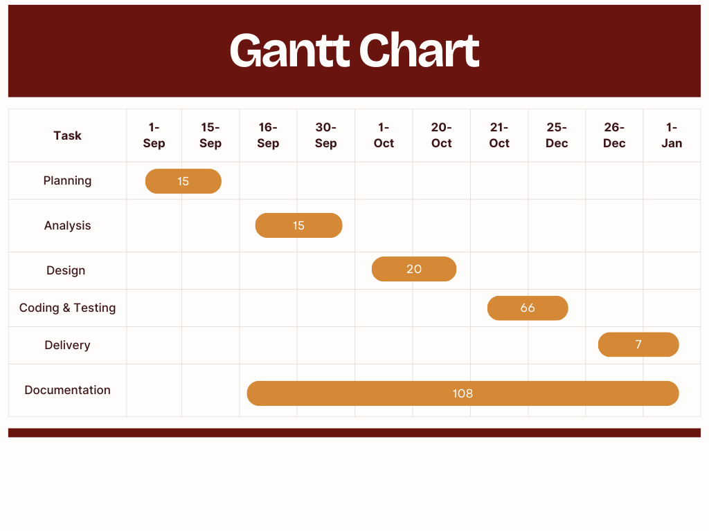
Figure 3. 3: Gantt Chart For Chat Application

3.1.3 Data Modeling: ER Diagram
The ER diagram of the Chat Application illustrates the relationship between the main entities: User, Message, and Channel. It defines how users exchange messages, create and join channels, and manage communication data within the system. This structure ensures efficient organization and retrieval of real-time messaging information.
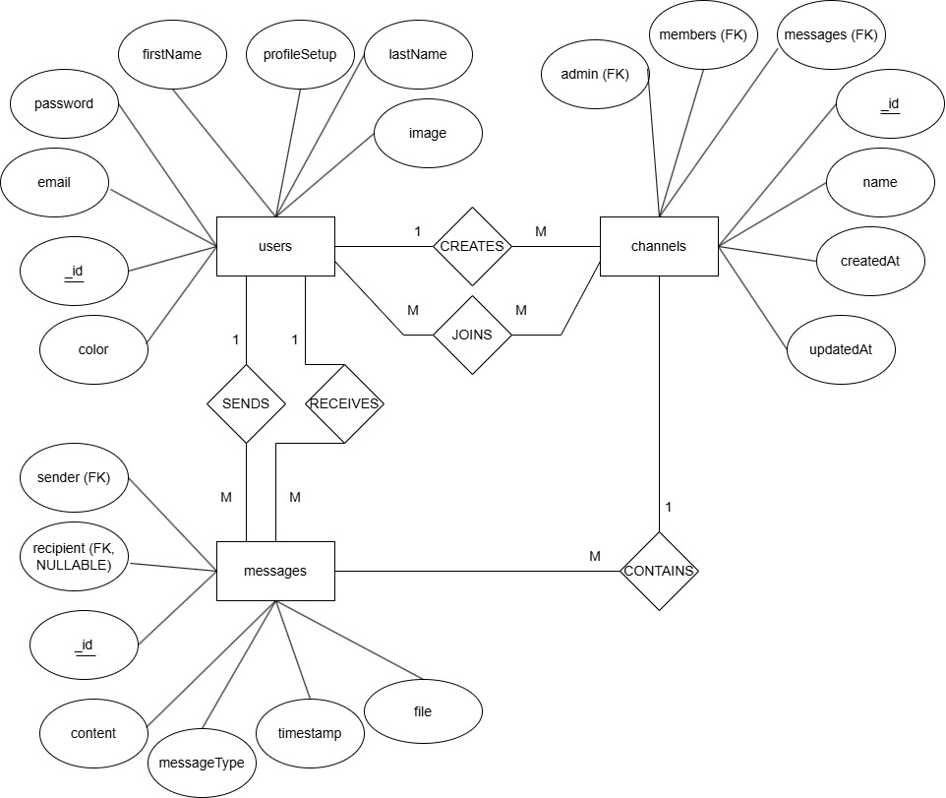
Figure 3. 4: ER Diagram For Chat Application

3.1.4 Process Modeling (DFD)
Level 0th DFD:
The Level 0 DFD provides an overall view of the Chat Application System as a single process interacting with external entities. In this case, the primary external entity is the User, which includes both members and administrators. Users interact with the system to register or log in, set up and manage their profiles, send and receive messages (text/file), and perform channel operations such as creating, joining, or managing chat channels. The system responds by authenticating users, storing and retrieving profile information, delivering messages, and providing channel data. This high-level diagram summarizes the system's core interactions without going into internal process details.

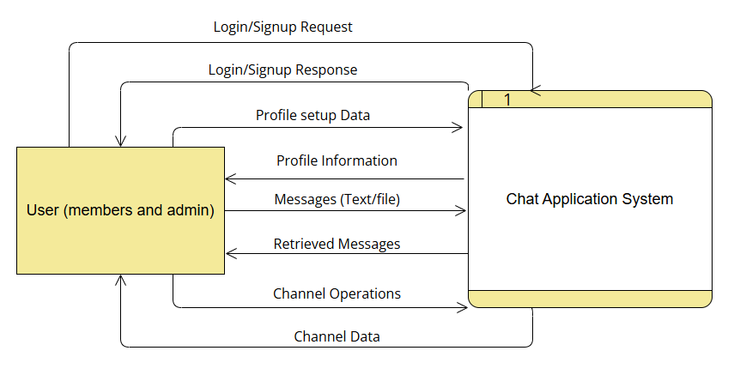
Figure 3. 5: Level 0 DFD For Chat Application
Level 1 DFD:
The Level 1 DFD decomposes the main process into sub-processes to show the internal workings of the Chat Application System. The system is divided into four core modules: Authenticate User (1.0), Manage Profile (2.0), Process Messages (3.0), and Manage Channels (4.0). Data stores such as Users, Messages, and Channels store the corresponding data for authentication, messaging, and channel management operations. Users interact with all modules to perform operations like login/signup, profile updates, sending/receiving messages, and creating or managing channels. The Channels data store also verifies user roles and permissions for channel operations, while the Messages data store maintains references to channels. This level provides a detailed view of how data flows internally between processes and data stores to support real-time communication and collaboration features efficiently.

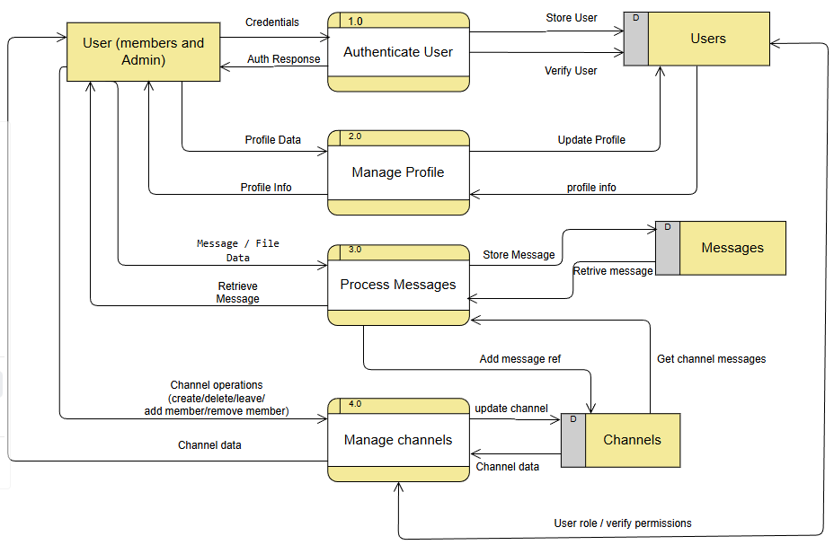
Figure 3. 6: Level 1 DFD For Chat Application

3.2 System Design
To realize the different functional requirement of the system in graphical form, different design diagram of the system has been prepared which are as follows:

3.2.1 Architectural Design
For this system, three tier architecture is used which includes user interface, web server and database. In this architectural design, basic structure of the system is shown.
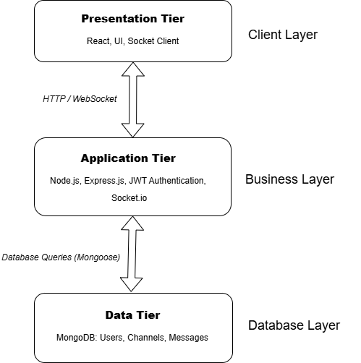
Figure 3. 7: Architectural Design For Chat Application

3.2.2 System Flowchart
Figure 3.8 shows the flowchart of the chat application. First, the user visits the website and either creates a new account or logs in using existing credentials. After successful authentication, the system checks whether the user has completed profile setup. If the profile is not completed, the user is redirected to the profile setup page. Once the profile setup is completed, the user is directed to the chat dashboard. From the dashboard, the user can initiate direct conversations by searching other users or continue existing chats. The user can also create or join channels to communicate in groups. Within chats and channels, users can send text messages, emojis, and files, as well as download shared files.

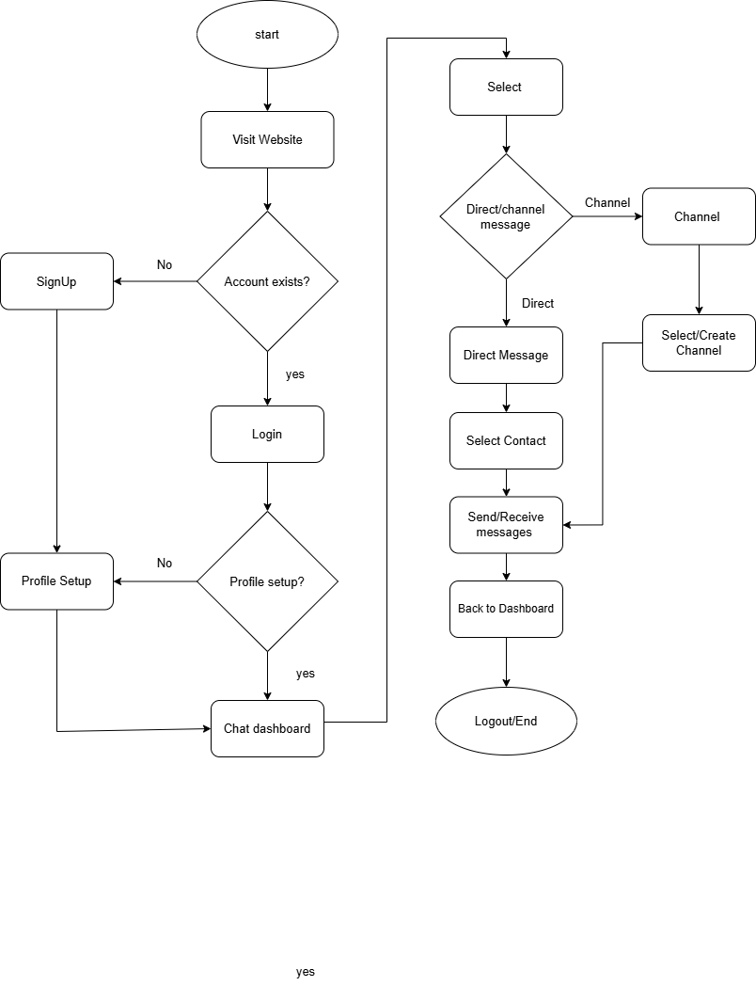
Figure 3. 8: System Flowchart For Chat Application

3.2.3 Database Schema Design
Figure 3.9 illustrates the database schema design of the Chat Application. The schema presents the basic structure of the system and shows how data is organized across different collections. The application consists of three main collections: Users, Messages, and Channels, each having its own set of attributes and a unique identifier (_id). In this MongoDB-based system, relationships between collections are maintained using ObjectId references rather than traditional foreign keys. These logical relationships are represented using arrows in the diagram to show how users, messages, and channels are interconnected. The schema design ensures efficient storage, retrieval, and management of real-time chat data while maintaining flexibility and scalability.
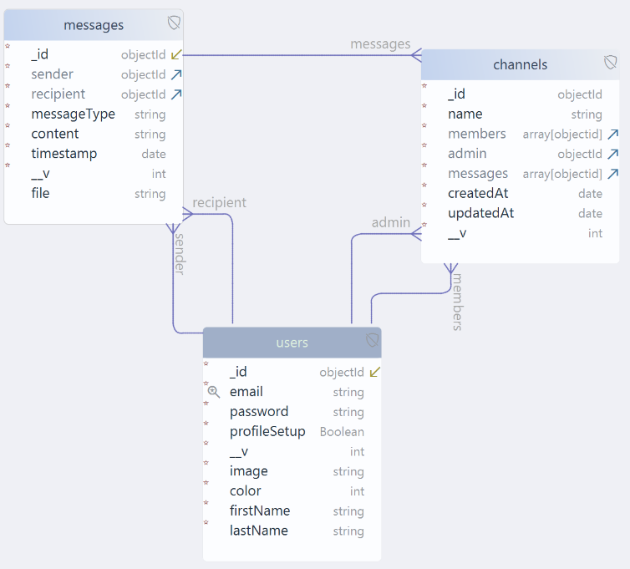
Figure 3. 9: Database Schema Design For Chat Application

3.2.4 Interface Design (UI/UX)
Interface design is used to define how the chat application looks and how users interact with the system. It provides a clear visual representation of system functionality before development begins. The UI design of the empty chat dashboard page is shown in Figure 10, the direct message dashboard in Figure 11, the channel message dashboard in Figure 12 and profile setup dashboard in Figure 13.
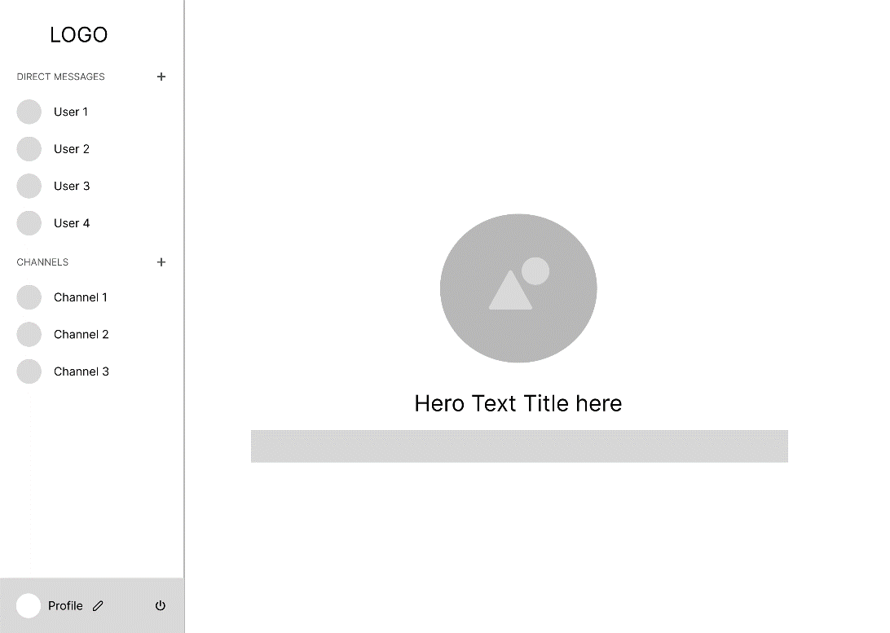
Figure 3. 10: Empty Chat Dashboard
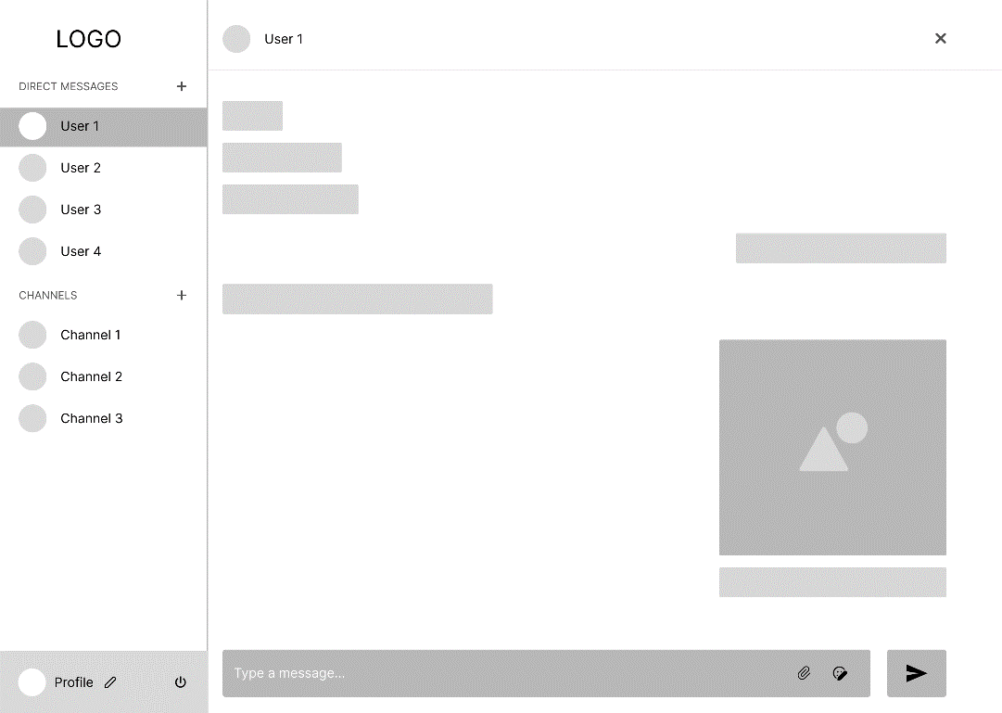
Figure 3. 11: Direct Message Dashboard
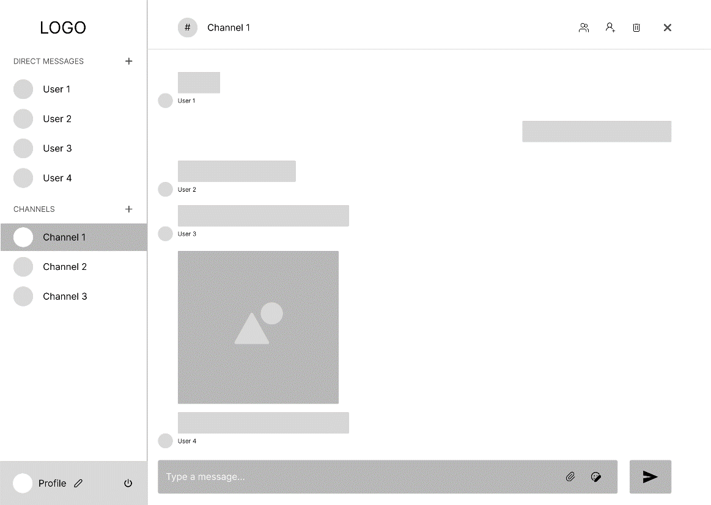
Figure 3. 12: Channel Message Dashboard
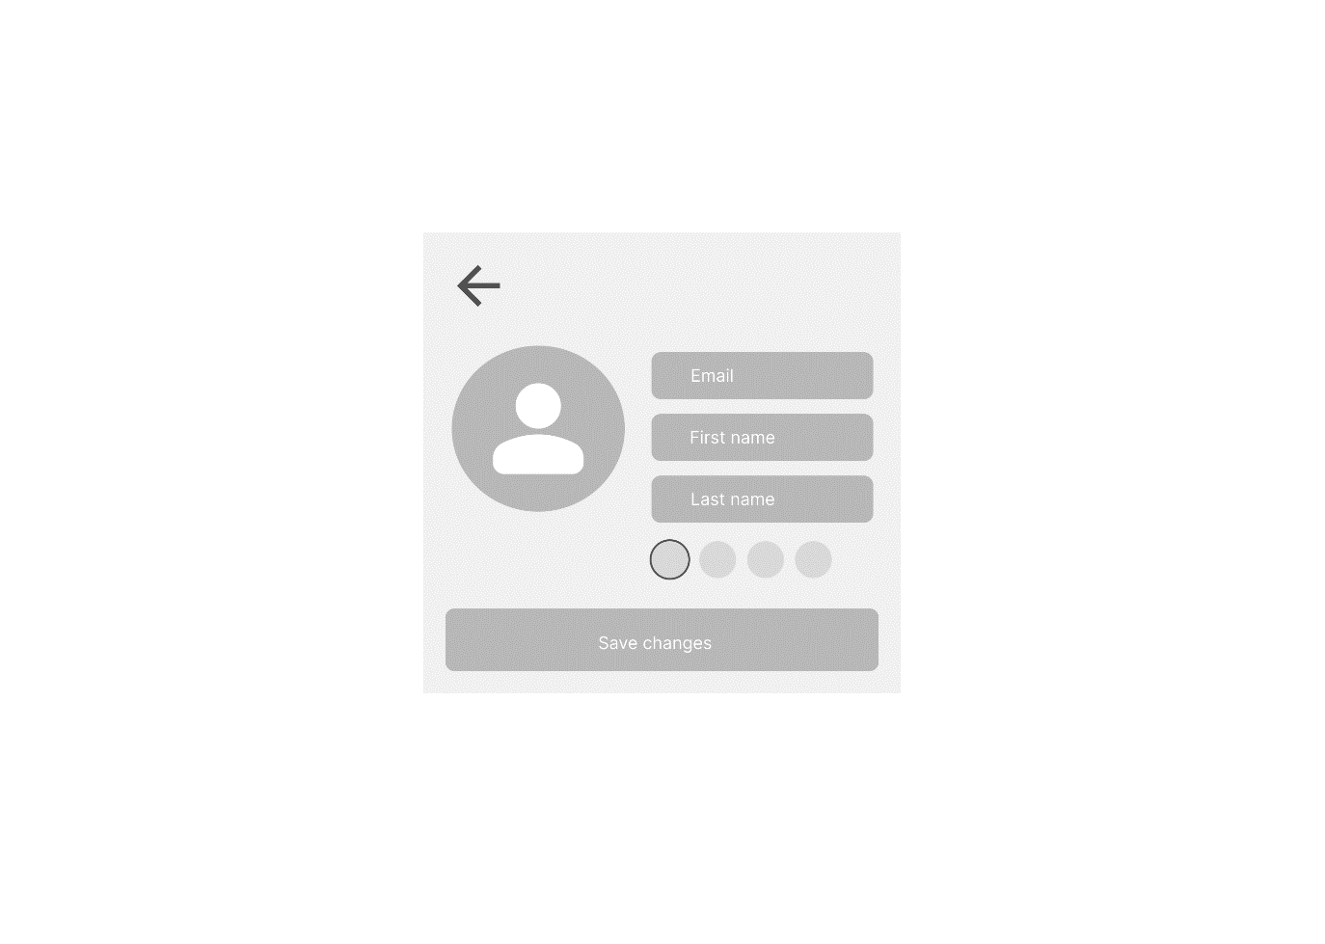
Figure 3. 13: Profile Setup Dashboard

3.2.5 Physical DFD
The Physical Data Flow Diagram represents how data is actually processed and transferred within the Chat Application System. It shows the interaction between the User (members and administrators) with system processes like authentication, profile management, message processing, and channel management. The diagram highlights the use of credentials, profile data, message/file data, and channel operations to perform core functions such as user verification, profile updates, message storage and retrieval, and channel data management. Each process communicates with its respective data store (users, messages, channels) through specific data flows like verify/store user, store/retrieve messages, and update channel data. The authentication result flows back to the user, confirming successful login or registration, while profile information and retrieved messages are also returned to enable seamless user interaction with the system.
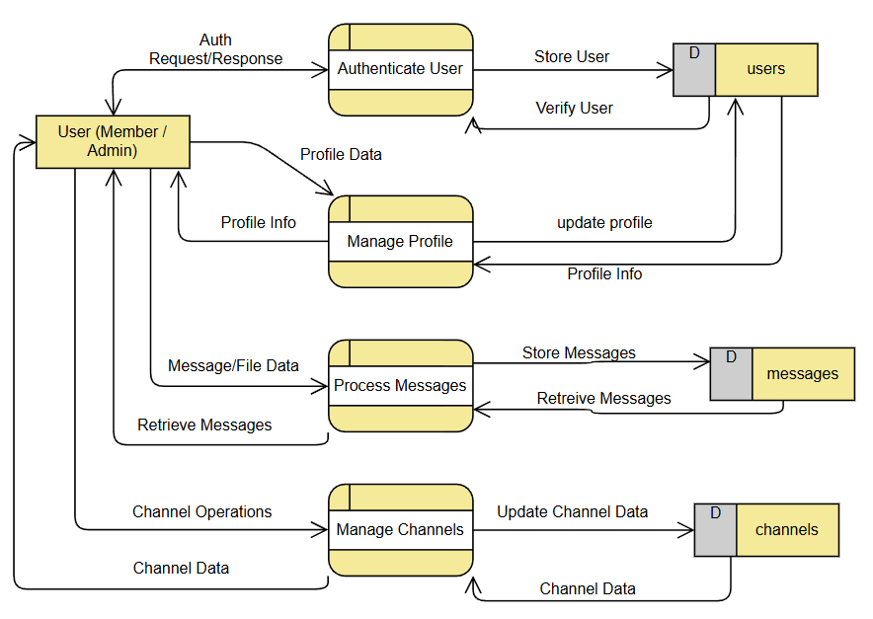
Figure 3. 14: Physical Level DFD for Chat Application

3.2.6 Sequence Diagram
The sequence diagram illustrates the interaction between the sender, frontend interface, backend server, encryption module, database, and socket server during real-time message transmission. When a user sends a message, it is encrypted before being stored in the database. The encrypted message is then processed and transmitted through the socket server to the intended recipient, ensuring secure and real-time communication.
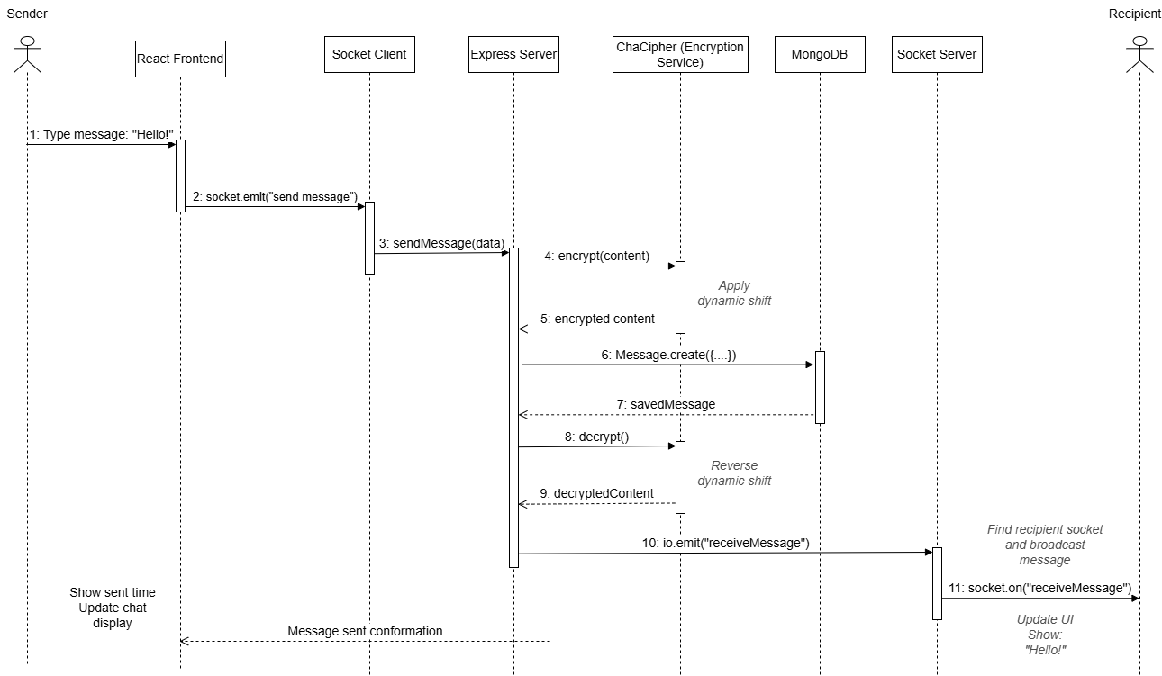
Figure 3. 15: Sequence Diagram For Chat Application

3.3 Algorithm Details
The Chat Application implements a custom message encryption algorithm named ChaCipher to ensure secure storage and transmission of chat messages. The algorithm encrypts every message before saving it in the database and decrypts it when the message is retrieved for display. This approach ensures message confidentiality and protects user communication from unauthorized access.
Unlike standard encryption libraries, ChaCipher is a manually implemented algorithm designed specifically for real-time chat systems. It uses a secret key to generate a numeric hash, which dynamically influences the encryption process. As a result, even identical messages produce different encrypted outputs based on character position and key-based shifting, enhancing security.
Purpose of the Algorithm
The primary objectives of the ChaCipher encryption algorithm are:
- To protect chat messages by converting readable text into an unreadable encrypted format before database storage.
- To support all types of characters, including emojis and special Unicode symbols.
- To demonstrate a custom, position-based encryption approach suitable for academic and learning purposes.
Algorithm Working Principle:
The algorithm works in two main phases: Encryption and Decryption.
Before encryption, the original message is first encoded into Base64 format to safely handle Unicode characters such as emojis. A numeric hash is generated from the secret key, which is used along with the character position and key characters to calculate a dynamic shift value. Each character in the message is then shifted using this value to produce encrypted output.
During decryption, the same secret key and hash value are used to reverse the shifting process. The encrypted message is converted back to its original Base64 representation and then decoded to restore the original text message.
Steps of the Algorithm:
- Start
- Accept the message input and secret key.
- Generate a numeric hash from the secret key.
- Encode the message into Base64 format to support Unicode characters.
- For each character in the encoded message:
a. Calculate a dynamic shift value using the secret key, character position, and key hash.
b. Apply the shift to encrypt the character.
- Store or transmit the encrypted message.
- During retrieval, apply the reverse shift using the same key and hash.
- Decode the decrypted Base64 string back to the original message.
- End
Mathematical Expression
$$H = \left| \sum_{j=0}^{m-1}{ASCII\left(k_{j}\right)}⋅31^{m-j-1}\right|$$
$$S_{i}= \left(ASCII\left(k_{i mod m}\right)+ i + H\right)mod 256$$
$$C_{i}= \left(P_{i}+ S_{i}\right)mod 256$$
$$P_{i}= \left(C_{i}- S_{i}+ 256\right)mod 256$$
Where k_{j} = ASCII value of key character at position j, m = key length, i = character position, H = key hash, P_{i}​ = plaintext character code, C_{i} ​ = ciphertext character code, S_{i}= shift value.
Pseudocode:
CLASS ChaCipher
PROPERTIES:
secretKey : STRING
keyHash : INTEGER

CONSTRUCTOR(secretKey)
IF secretKey IS NULL THEN
secretKey ← "DefaultChatKey123"
ENDIF
this.secretKey ← secretKey
this.keyHash ← GenerateKeyHash(secretKey)
END CONSTRUCTOR

FUNCTION GenerateKeyHash(key)
hash ← 0
FOR i FROM 0 TO LENGTH(key) - 1 DO
hash ← (hash × 31) + ASCII(key[i])
END FOR
RETURN ABS(hash)
END FUNCTION
FUNCTION Encrypt(message)
IF message IS NULL OR message IS NOT STRING THEN
RETURN message
ENDIF
Base64Message ← ENCODE_BASE64(message)
EncryptedText ← ""
KeyLength ← LENGTH(secretKey)
FOR i FROM 0 TO LENGTH(Base64Message) - 1 DO
CharCode ← ASCII(Base64Message[i])
KeyChar ← secretKey[i MOD KeyLength]
Shift ← (ASCII(KeyChar) + i + keyHash) MOD 256
EncryptedChar ← (CharCode + Shift) MOD 256
EncryptedText ← EncryptedText + CHARACTER(EncryptedChar)
END FOR
RETURN EncryptedText
END FUNCTION

FUNCTION Decrypt(encryptedMessage)
IF encryptedMessage IS NULL OR encryptedMessage IS NOT STRING THEN
RETURN encryptedMessage
ENDIF
DecryptedBase64 ← ""
KeyLength ← LENGTH(secretKey)
FOR i FROM 0 TO LENGTH(encryptedMessage) - 1 DO
CharCode ← ASCII(encryptedMessage[i])
KeyChar ← secretKey[i MOD KeyLength]
Shift ← (ASCII(KeyChar) + i + keyHash) MOD 256
DecodedChar ← (CharCode - Shift) MOD 256

IF DecodedChar < 0 THEN
DecodedChar ← DecodedChar + 256
ENDIF
DecryptedBase64 ← DecryptedBase64 + CHARACTER(DecodedChar)
END FOR
OriginalMessage ← DECODE_BASE64(DecryptedBase64)
RETURN OriginalMessage
END FUNCTION
END CLASS
Example Scenario:
When a user sends a message such as “Hello 😊”, the system first converts the message into a Base64-encoded format to safely represent the emoji. The encoded message is then encrypted using the ChaCipher algorithm and stored in the database in encrypted form. When the recipient opens the chat, the system decrypts the stored message using the same secret key and displays the original readable message to the user.

Chapter 4: Implementation and Testing

4.1 Implementation

4.1.1 Tools Used
The following tools and technologies were used during the implementation of the Chat Application:
Frontend Tools
- React js
React.js is used to build the user interface of the application. It enables a component-based architecture, which makes the UI reusable, efficient, and easy to manage. React helps in rendering dynamic chat components such as message lists, chat windows, and user status updates.
- Tailwind css
Tailwind CSS is used for styling the application. It provides utility-based CSS classes that help in designing a clean, modern, and responsive user interface. Tailwind ensures consistent design across different screen sizes and devices.
- Shadcn UI
ShadCN UI components are used to enhance the visual appearance and usability of the application. These pre-built and customizable components help maintain design consistency and improve user experience.
- Zustand (State Management)
Zustand is used for managing global application state such as authenticated user data, active chats, and messages. It provides a lightweight and efficient alternative to traditional state management solutions.
- Axios
Axios is used for handling API requests between the frontend and backend. It enables smooth communication for authentication, message retrieval, and file operations.

Backend Tools
- Node.js and Express.js
Node.js is used as the runtime environment, while Express.js is used to build RESTful APIs. These APIs handle user authentication, message processing, file uploads, and database interactions. Express provides a lightweight and flexible framework for backend development.
- MongoDB
MongoDB is used as the database for storing user data, encrypted messages, chat information, and file references. Its NoSQL structure allows efficient handling of unstructured data and supports scalability for real-time applications.
- JWT (JSON Web Tokens)
JWT is used for secure authentication and authorization. Tokens are generated during login and verified on each request to ensure that only authenticated users can access protected routes.
- Socket.io (Real-Time Communication)
Socket.io is used to enable real-time messaging between users. It allows instant message delivery and supports features such as personal chats and group chats.
- Multer (File Handling)
Multer is used to handle file and image uploads within chat conversations. It enables users to share media files securely and efficiently.
- Custom Encryption Algorithm
A custom encryption algorithm is implemented to encrypt messages before saving them to the database and decrypt them when retrieved. This ensures message confidentiality and protects sensitive communication data.

4.1.2 Implementation Details of Modules
- User Authentication Module
The User Authentication Module is responsible for handling user registration and login functionalities within the chat application. It validates user credentials using secure authentication techniques and generates JSON Web Tokens (JWT) upon successful login. These tokens are used to maintain secure user sessions and restrict access to protected areas of the application. The module ensures that only authenticated users can access features such as messaging, profile management, and channel operations, while also handling token expiration and unauthorized access scenarios.
- User Profile Management Module
The User Profile Management Module allows users to set up and manage their personal profile information. Users can update their first name, last name, profile picture, and display color. Profile picture upload is optional, and if no image is provided, the system displays an avatar generated from the first character of the user’s first name. This module retrieves and updates profile data from the database and ensures that the latest profile information is reflected throughout the application.
- Direct Messaging Module
The Direct Messaging Module enables one-to-one communication between users. It allows users to search for other registered users and initiate new conversations or continue existing ones. The module supports sending text messages, emojis, images, and files. Messages are encrypted before being stored in the database and decrypted during retrieval to ensure secure communication. Real-time message delivery is achieved using WebSocket technology, allowing instant message exchange without requiring page refreshes.
- Channel (Group Chat) Management Module
The Channel Management Module handles group communication functionality within the application. It allows users to create channels and participate in group conversations. Each channel has an administrator who has the authority to add or remove members and delete the channel when necessary. Channel members are allowed to leave the channel voluntarily. This module manages channel metadata, member lists, and message associations, ensuring proper access control and role-based permissions within group chats.
- File Handling and Media Module
The File Handling and Media Module manages the uploading, storage, and retrieval of files and images shared within chats. It supports file sharing in both direct messages and channel conversations. The module ensures that uploaded files are properly stored and can be securely downloaded by authorized users. Validation mechanisms are applied to maintain file integrity and prevent invalid uploads.
- Real-Time Communication Module
The Real-Time Communication Module is responsible for enabling instant message delivery across the system. It uses socket-based communication to transmit messages in real time between users and channel members. This module ensures synchronization of chat data across multiple clients and updates chat interfaces dynamically, providing a smooth and responsive messaging experience.
- Data Security and Encryption Module
The Data Security and Encryption Module ensures the confidentiality and integrity of user messages. Before messages are stored in the database, they are encrypted using a dynamic shift cipher algorithm. When messages are retrieved for display, the module decrypts the content securely. This approach protects sensitive communication data from unauthorized access and enhances overall system security.

4.2 Testing
System testing is done by giving different training and testing datasets. This test is done to evaluate whether the system is providing accurate summary or not. During the phase of the development of the system, our system is tested time and again. The series of testing conducted are as follow:

4.2.1 Test Cases for Unit Testing
In unit testing, the system is developed using a modular approach, where each module is tested independently. Each module is refined until the expected output is achieved. Input forms are also tested to ensure that invalid or incorrect data is not accepted by the system.

Table 4. 1: Test Case for Authentication Module
Test ID | Description | Input Data | Expected Result | Status
TC_AUTH_01 | Login with valid credentials | Email: anjan@gmail.com  Password: validPassword | User authenticated, JWT token generated | pass
TC_AUTH_02 | Login with incorrect password | Email: anjan@gmail.com  Password: wrongPassword | Authentication fails with error message | pass
TC_AUTH_03 | Login with unregistered email | Email: unknown@gmail.com  Password: anyPassword | Returns "User not found" error | pass
TC_AUTH_04 | Login with missing email | Password: validPassword | Returns validation error | pass
TC_AUTH_05 | Login with missing password | Email: anjan@gmail.com | Returns validation error | pass
TC_AUTH_06 | Signup with valid details | Email: new@gmail.com  Password: pass123  Name: John Doe | User account created successfully | pass
TC_AUTH_07 | Signup with existing email | Email: anjan@gmail.com (existing) | Returns "Email already exists" error | pass
TC_AUTH_08 | JWT token generation | Valid credentials | JWT token included in response | pass
TC_AUTH_09 | Verify password hashing | Password: plaintext123 | Password stored as bcrypt hash in DB | pass
TC_AUTH_10 | Token expiration validation | Expired JWT token | Returns "Token expired" error | pass

Table 4. 2: Test Case for Profile Module
Test ID | Description | Input Data | Expected Result | Status
TC_PROFILE_01 | Update profile with valid first and last name | First Name: AnjanLast Name: Khadka | Profile updated successfully | Pass
TC_PROFILE_02 | Update profile with profile picture | First Name: AnjanLast Name: KhadkaProfile Image: image.jpg | Profile updated and image stored | Pass
TC_PROFILE_03 | Update profile without profile picture | First Name: AnjanLast Name: KhadkaNo image uploaded | Profile updated successfully | Pass
TC_PROFILE_04 | Delete existing profile picture | Delete Image Flag: true | Profile image removed successfully | Pass
Test ID | Description | Input Data | Expected Result | Status
TC_PROFILE_05 | Update profile with empty first name | First Name: ""Last Name: Khadka | Returns validation error | Pass
TC_PROFILE_06 | Update profile with empty last name | First Name: Anjan Last Name: "" | Returns validation error | Pass
TC_PROFILE_07 | Update profile with invalid image format | Profile Image: file.txt | Returns invalid file format error | Pass
TC_PROFILE_08 | Fetch user profile | User ID | Profile data retrieved successfully | Pass
TC_PROFILE_09 | Fetch profile without authentication | No JWT token | Returns unauthorized error | Pass
TC_PROFILE_10 | Display profile character when no image exists | First Name: AnjanNo profile image | First letter of name displayed as avatar | Pass

Table 4. 3: Test Cases for Direct Messaging Module for Chat Application
Test ID | Description | Input Data | Expected Result | Status
TC_MSG_01 | Search user to initiate new conversation | Search Query: user email/username | User list returned matching search | Pass
Test ID | Description | Input Data | Expected Result | Status
TC_MSG_02 | Initiate new conversation with searched user | Recipient User ID | New conversation created successfully | Pass
TC_MSG_03 | Send text message in new conversation | Recipient IDMessage: "Hello" | Message sent and stored successfully | Pass
TC_MSG_04 | Send text message in existing conversation | Conversation IDMessage: "Hi again" | Message sent successfully | Pass
TC_MSG_05 | Send emoji message | Recipient IDEmoji: 😀 | Emoji message sent successfully | Pass
TC_MSG_06 | Send image file | Recipient IDImage: photo.jpg | Image uploaded and message stored | Pass
TC_MSG_07 | Send document/file | Recipient IDFile: report.pdf | File uploaded and message stored | Pass
TC_MSG_08 | Download shared file | Message ID | File downloaded successfully | Pass
TC_MSG_09 | Fetch message history for conversation | Conversation ID | Messages retrieved in correct order | Pass
Test ID | Description | Input Data | Expected Result | Status
TC_MSG_10 | Send message without authentication | No JWT token | Returns unauthorized error | Pass
TC_MSG_11 | Send message with empty content | Recipient IDMessage: "" | Returns validation error | Pass
TC_MSG_12 | Search user with invalid keyword | Search Query: "###" | Returns empty result set | Pass

Table 4. 4: Test Cases for Channel Module for Chat Application
Test ID | Description | Input Data | Expected Result | Status
TC_CH_01 | Create new channel | Channel Name: “Dev Team” | Channel created successfully | Pass
TC_CH_02 | Add member to channel (Admin only) | Channel IDUser ID (new member) | Member added to channel | Pass
TC_CH_03 | Remove member from channel (Admin only) | Channel IDUser ID (member) | Member removed from channel | Pass
TC_CH_04 | Delete channel (Admin only) | Channel ID | Channel deleted successfully | Pass
Test ID | Description | Input Data | Expected Result | Status
TC_CH_05 | Member leaves channel | Channel IDUser ID (member) | User removed from channel members | Pass
TC_CH_06 | Non-admin tries to add member | Channel IDUser ID | Returns unauthorized error | Pass
TC_CH_07 | Non-admin tries to remove member | Channel IDUser ID | Returns unauthorized error | Pass
TC_CH_08 | Non-admin tries to delete channel | Channel ID | Returns unauthorized error | Pass
TC_CH_09 | Send text message in channel | Channel IDMessage: “Hello team” | Message sent and stored successfully | Pass
TC_CH_10 | Send emoji message in channel | Channel IDEmoji: 😀 | Emoji message sent successfully | Pass
TC_CH_11 | Send image/file in channel | Channel IDFile: design.png | File uploaded and message stored | Pass
TC_CH_12 | Download channel shared file | Message ID | File downloaded successfully | Pass
TC_CH_13 | Fetch channel messages | Channel ID | Channel messages retrieved successfully | Pass
Test ID | Description | Input Data | Expected Result | Status
TC_CH_14 | Send message by non-member | Channel IDMessage | Returns access denied error | Pass
TC_CH_15 | Leave channel without authentication | No JWT token | Returns unauthorized error | Pass

4.2.2 Test Cases for System Testing
In system testing, whole system is tested as below:

Table 4. 5: Test Case for System Testing for Chat Application
Test ID | Test Scenario | Test Description | Expected Result | Status
ST_01 | Application Launch | User visits the chat application website | System Auth page loads successfully | Pass
ST_02 | User Registration | User registers with valid email and password | Account created successfully | Pass
ST_03 | User Login | User logs in with valid credentials | User authenticated and redirected to dashboard | Pass
Test ID | Description | Input Data | Expected Result | Status
ST_04 | Profile Setup | User completes profile setup after login | Profile setup completed successfully | Pass
ST_05 | Direct Message Initiation | User searches another user and starts a chat | New conversation initiated successfully | Pass
ST_06 | Send Direct Message | User sends text/emoji in direct chat | Message sent and displayed correctly | Pass
ST_07 | File Sharing | User uploads and downloads file/image in chat | File uploaded and downloaded successfully | Pass
ST_08 | Channel Creation | User creates a new channel | Channel created with user as admin | Pass
ST_09 | Channel Member Management | Admin adds/removes members from channel | Members updated successfully | Pass
ST_10 | Channel Messaging | User sends message in channel | Message delivered to all channel members | Pass
ST_11 | Leave Channel | Channel member leaves the channel | User removed from channel | Pass
Test ID | Description | Input Data | Expected Result | Status
ST_12 | Delete Channel | Admin deletes the channel | Channel deleted successfully | Pass
ST_13 | Real-Time Messaging | User sends message to another user | Message delivered instantly | Pass
ST_14 | Logout | User logs out from the system | User logged out and redirected to login page | Pass

Chapter 5: Conclusion and Future Recommendations

5.1 Lesson Learnt/ Outcome
During the development of this project, several important lessons were learned. Teamwork played a key role in completing different tasks efficiently and sharing responsibilities. The project helped improve problem-solving skills by addressing technical challenges related to real-time messaging, authentication, and data security. Report writing skills were enhanced through proper documentation of system analysis, design, and implementation. The project also strengthened understanding of system design concepts such as modular architecture and secure data flow. Additionally, effective time management was learned by planning tasks, meeting deadlines, and balancing development and documentation work.

5.2 Conclusion
The Chat Application developed using the MERN stack successfully meets the objectives of providing secure, real-time, and user-friendly communication. The system supports personal and group chats, file sharing, emoji interaction, and real-time messaging using socket technology. Authentication using JWT and message encryption ensures data privacy and secure access for users.
Overall, the project demonstrates how modern web technologies can be combined to build a scalable and efficient communication platform. The use of structured code, responsive design, and secure backend implementation makes the system reliable and suitable for real-world usage.

5.3 Future Recommendations
Although the current system fulfills its core objectives, several enhancements can be considered in the future. Features such as message reactions, read receipts, and online/offline status indicators can enhance user experience. Push notifications can be added for better user engagement. Additionally, video and voice calling features can be integrated to expand communication capabilities. Deploying the application on cloud platforms and optimizing performance for large user bases would further improve scalability and reliability.

References

[1] | "MDN Web Docs – WebSockets," [Online]. Available: https://developer.mozilla.org/en-US/docs/Web/API/WebSockets_API.
[2] | "RFC 6455 – The WebSocket Protocol," [Online]. Available: https://datatracker.ietf.org/doc/html/rfc6455.
[3] | "MongoDB Documentation – Application Design," [Online]. Available: https://www.mongodb.com/docs/manual/core/data-modeling-introduction/.
[4] | "Node.js," [Online]. Available: https://nodejs.org/en/learn/getting-started/introduction-to-nodejs.
[5] | "JSON WEB TOKEN - jwt.io," [Online]. Available: https://www.jwt.io/introduction.
[6] | "osasp.org," [Online]. Available: https://owasp.org/www-project-top-ten/.
[7] | "react.dev," [Online]. Available: https://react.dev/learn.
[8] | "Nielsen Norman Group," [Online]. Available: https://www.nngroup.com/articles/usability-101-introduction-to-usability/.
[9] | "redhat," [Online]. Available: https://www.redhat.com/en/topics/integration/what-is-event-driven-architecture.

APPEDNICES

- Signup
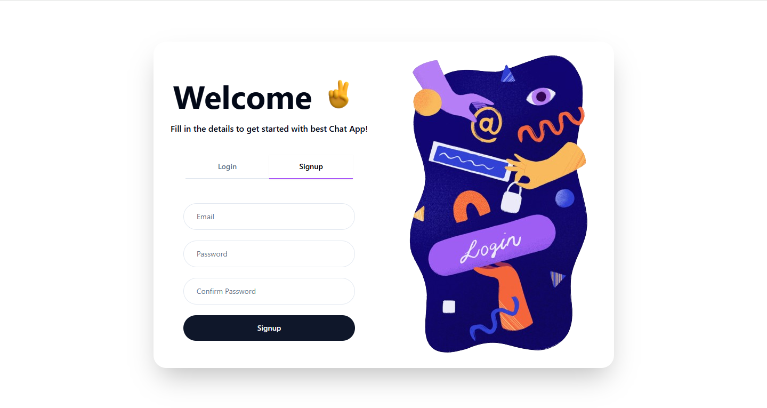
- Profile Setup
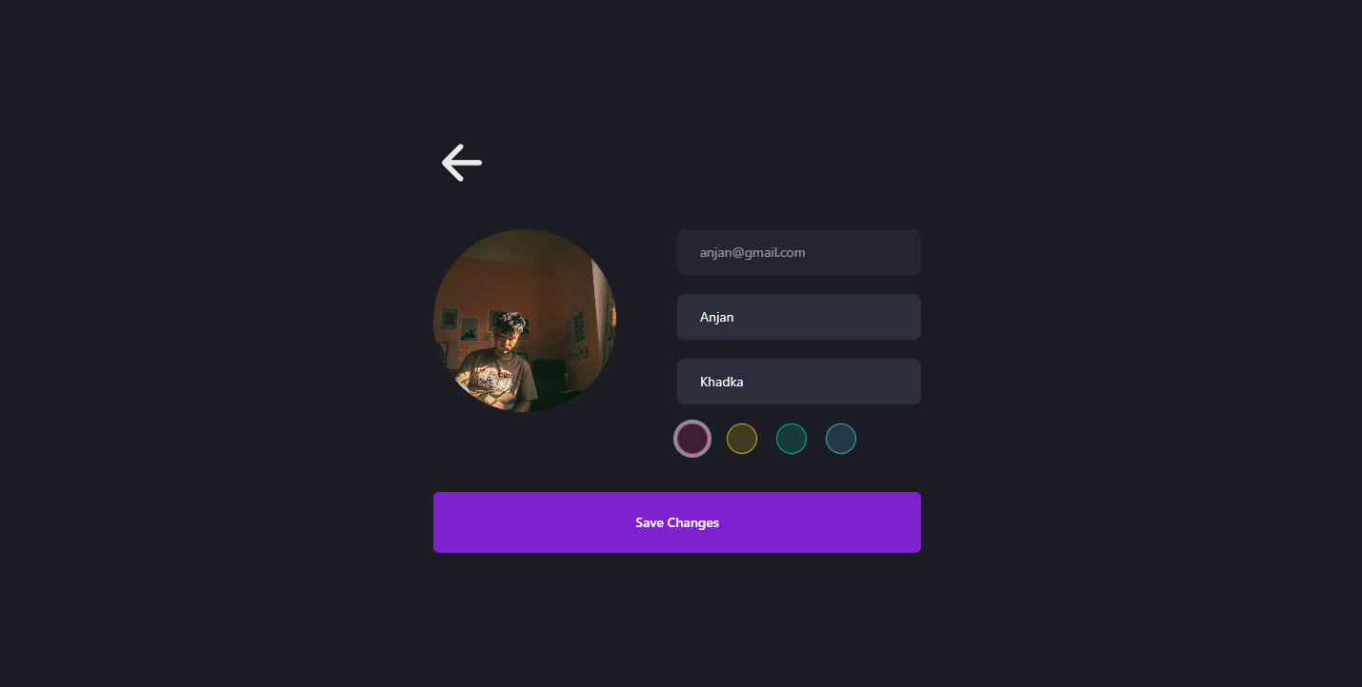

- Dashboard
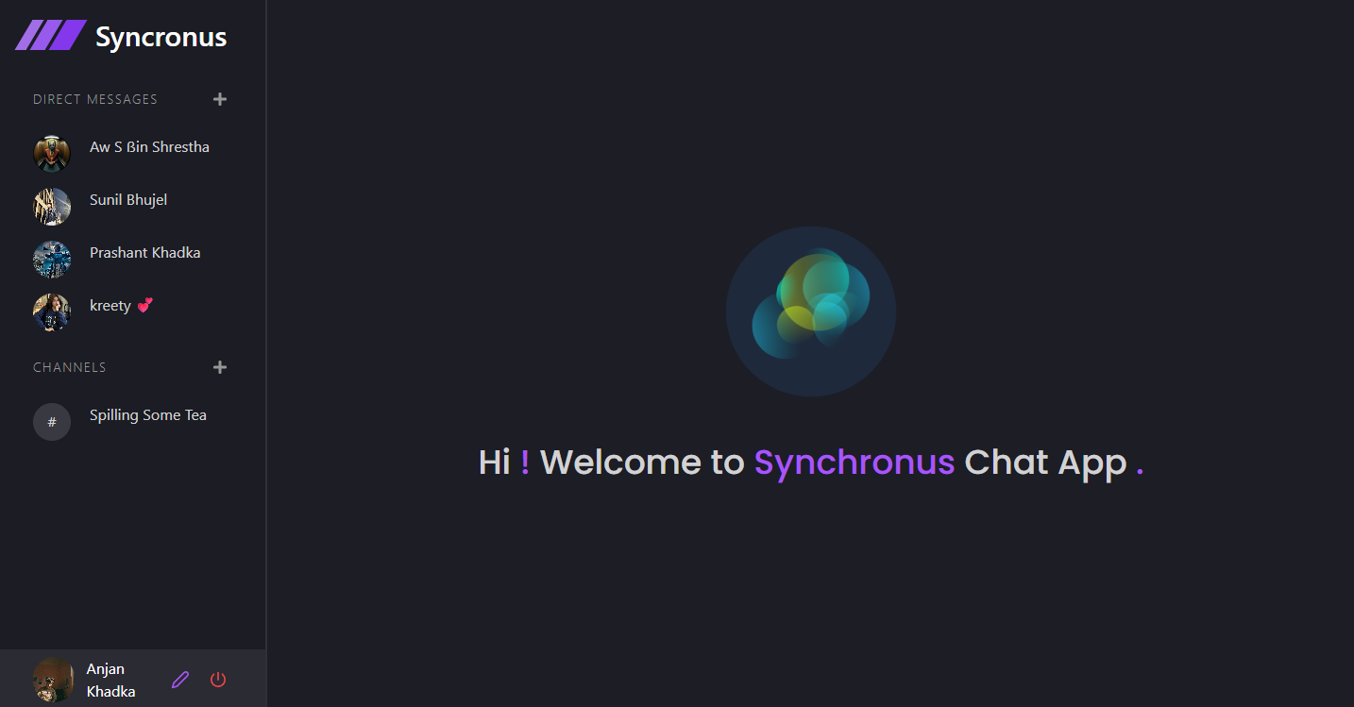
- Direct Message
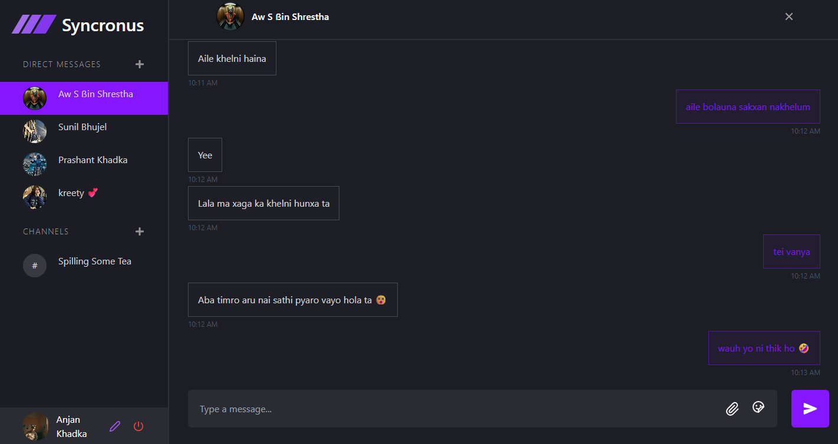

- Channel Message
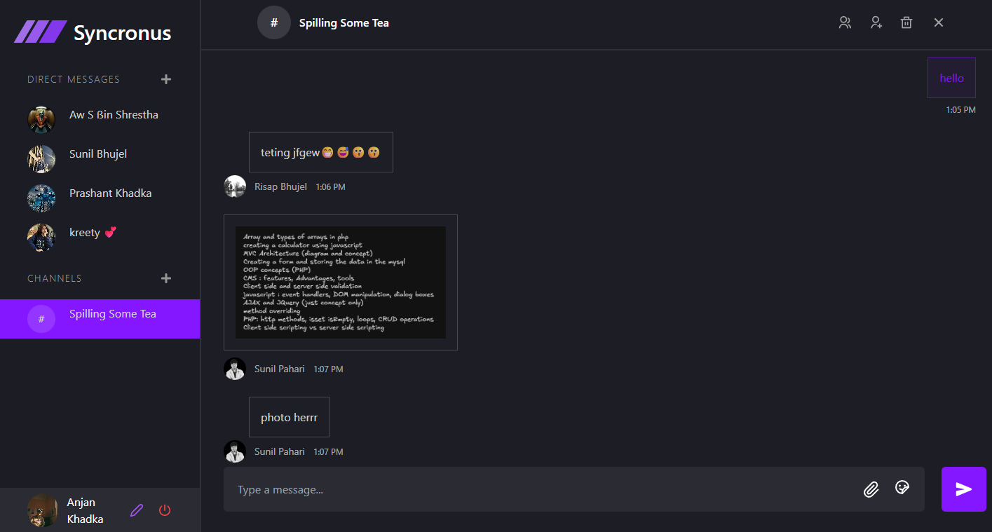

- Create Channel
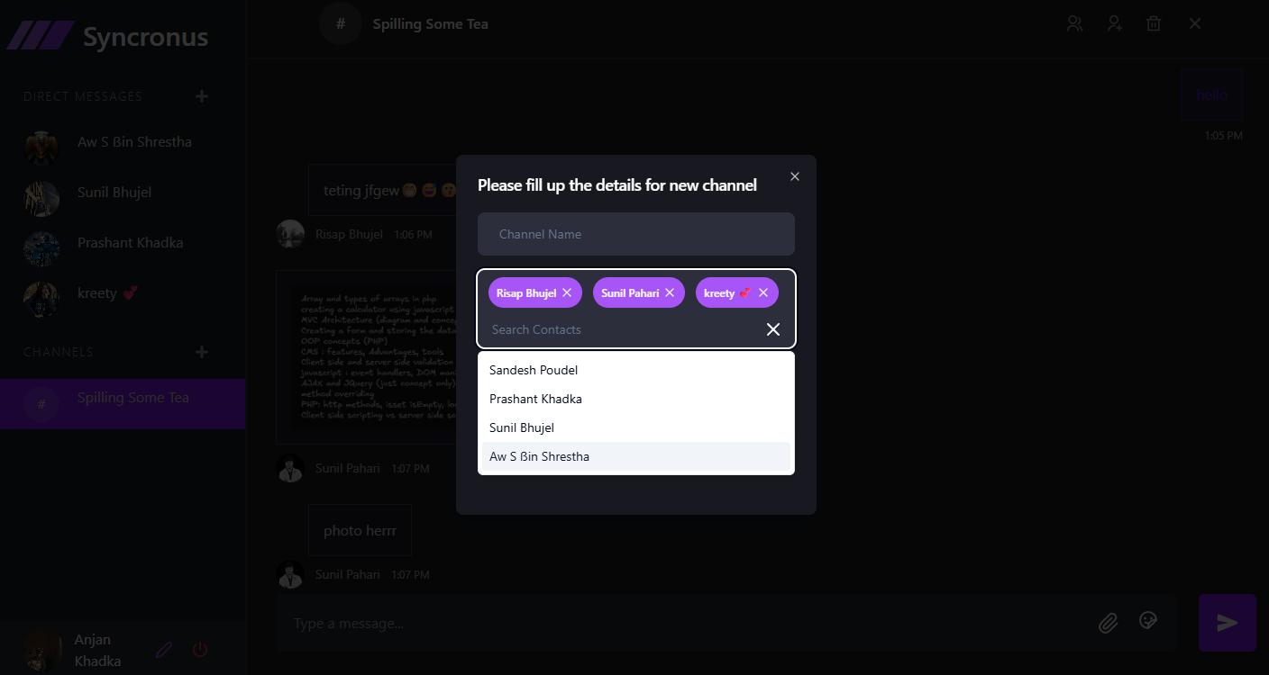

- Search User
